**JDBC Sampler:**

For these sampler we need MYSql in local machine.

Creating a new Thread and Naming it JDBC Sampler.

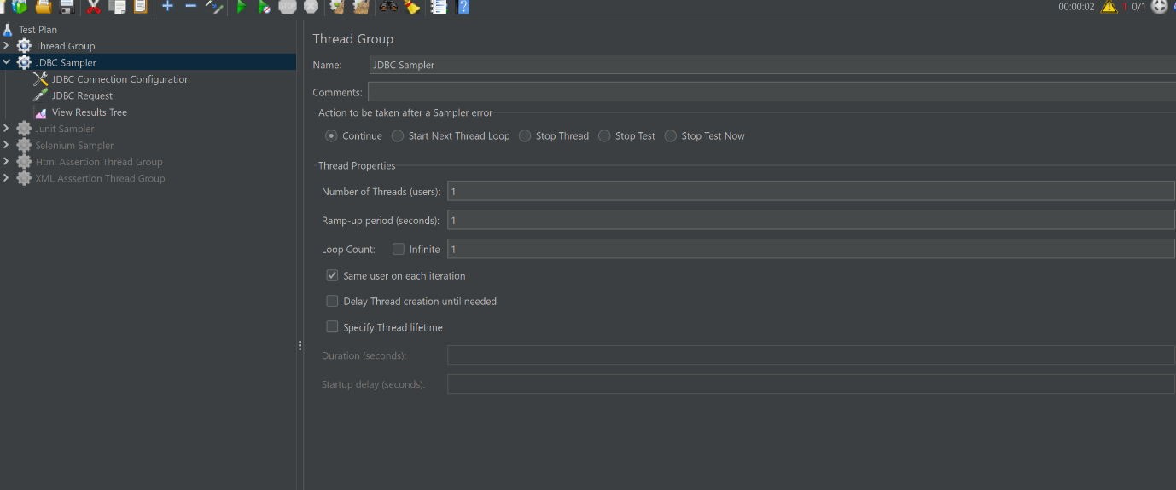

**JDBC Steps**

Downloading database specific jar and placing it in lib

<https://dev.mysql.com/downloads/connector/j/>

We need zip file of --

Mysql.connector.j.8.2.0

Copy aboth downloaded path and paste it in lib folder of jmeter.

Variable name is do pool used to connect to jdbc request.

In jdbc request:

We need to select qury statement

Select * from table name;

